Appendix 1: Assignment submission cover sheet
ASSUGNMENT SUBMISSION COVER SHEET
Student Id:
cse25-207
Student names:
Lefika Oteng Rantsebele
Student email:
cse25-207@thuto.bac.ac.bw
Cohort:
cse1-1

Assignment title:
SCIS WMD_2026 A01
Date of Submission:
20 May 2026

Programme Study:
BUSINESS INTELLIGENCE AND DATA ANALYSTICS
Year of Study:
Year1
Intellectual property Statement
By checking the box below, I certify that this assignment is my own work and is free from plagiarism. I understand that the assignment maybe checked for plagiarism by electronics or other means and maybe transferred and stored in a database for the purposes of data-matching to help detect plagiarism. The assignment has not previously been submitted for assessment in any other unit or any other institution.
have read and understood the Botswana Accountancy College plagiarism guidelines
policy
✓ agree Signature.....L.O.Rantsebele............
Date..........22/05/2026.......................

Web Specifications
1a. Website Objective and Goals
Objective:
The main objective of the Growth Point Printers website is to create a professional online presence for a printing business and provide customers with easy access to business information and services.
The website was developed to help the business promote its printing services, improve communication with customers, and increase customer engagement through a modern and user-friendly online platform.
Website Goals
The goals of the website include:
- To advertise the company’s printing services online
- To provide customers with information about the business
- To display previous work through the gallery page
- To allow customers to contact the business easily
- To collect customer feedback using online forms
- To create a professional and visually appealing business image
- To improve customer interaction and accessibility through a responsive website
b. Target Audience
Target Audience:
- Age Group: 16 – 45 years
- Gender: All genders
- Location: Local customers (e.g., Gaborone and surrounding areas)
- Occupation: Students, small business owners, event organizers, and corporate clients

Technical Aptitude:
- Basic to intermediate internet users
- Mostly mobile phone users
- Familiar with social media and browsing websites
- Prefer simple, fast, and visually appealing websites
- Users prefer websites that load quickly
- Users expect navigation to work on touch devices

c. Type of Website / Content
Type of Website:
This will be a business/service website with elements of:
- Portfolio (to showcase previous work)
- Informational website (services and pricing)
- Interactive website (contact/feedback form)

Content Included:
- Home page (introduction and highlights)
- About page (information about the designer)
- Services page (design services offered)
- Portfolio gallery (design work samples)
- Contact page (form, email, phone details

[ HOME ]
|
------- -------------------------------------------------------
| | | | |
[ ABOUT ] [ SERVICES ] [ GALLERY ] [ CONTACT ] [ FEEDBACK ]
|
--------- -----------------
| | |
[POSTERS] [FLYERS] [BANNERS]

Portfolio Categories
- Posters
- Business Cards
- Banners
- Flyers

Services Categories
- Poster Design
- Business Card Design
- Banner Design
- Flyer Design

d. User Requirements and Justification
- Users need to find the printing services available (posters, flyers, banners, business cards) quickly.
Justification: Customers usually decide fast and don’t want to search multiple pages.
- Users need to view a portfolio/gallery of past work.
Justification: Proof of quality and design style increases trust and enquiries.
- Users need pricing/service information (even starting prices or package ranges).
Justification: Helps users estimate cost before contacting you.
- Users need to contact the business easily using a contact form and/or email/phone details.
Justification: A simple contact method increases conversions from visitors.
- Users need the website to be mobile-friendly and fast-loading.
Justification: Most users will browse on phones and abandon slow or broken layouts.

2. Information Design & Taxonomy

2.1 Information architecture (content categorization)
The website content is organized into main sections based on user tasks:
- Home (index.html): brief introduction + highlights of services and quick access to key pages
- Services (services.html): lists the printing services offered (poster, business card, banner, flyer design)
- Gallery (gallery.html): showcases completed designs, grouped by type
  - Categories: Posters, Business Cards, Banners, Flyers
- About (about.html): describes the designer/business background and credibility
- Contact (contact.html): provides a contact form plus email/phone details for enquiries
- Feedback (feedback.html): provides feedback form plus emails for enquiries
This structure matches user goals: learn services → view examples → contact for orders.

2.2 Navigation plan / site map logic
Navigation follows a top-level menu so users can move between pages easily:
- From Home, users can go directly to Services, Gallery, About, and Contact.
- The Gallery page provides categorized browsing to help users find relevant work quickly (e.g., Posters, Flyers).
- The Contact page is always reachable to support conversion (requesting a quote).
- The Feedback paged is also reachable to users to tell us about their experience.

Site Map
Home page
index.html
Services page services.html
Aout page
about.html
Gallery page
gallery.html
Contact page
contact.html
Feedback page
feedback.html

Flow chart

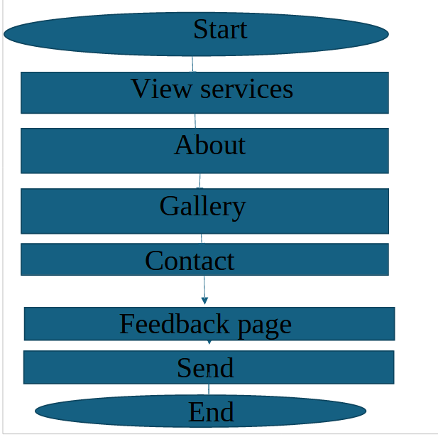

3.Page Template
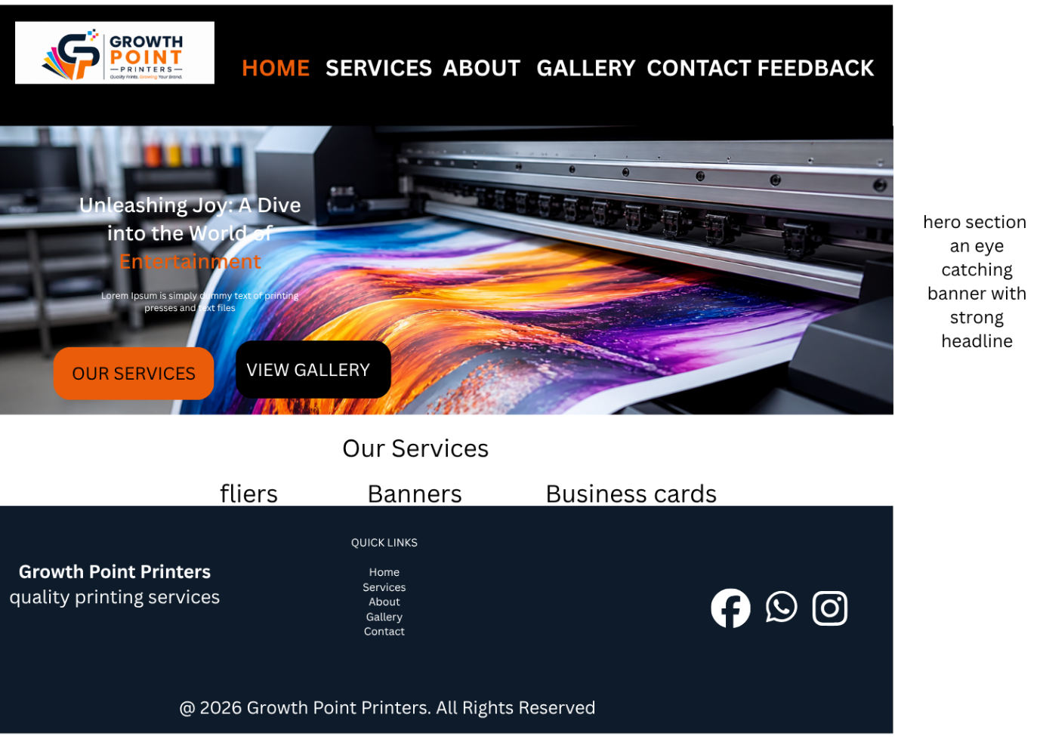
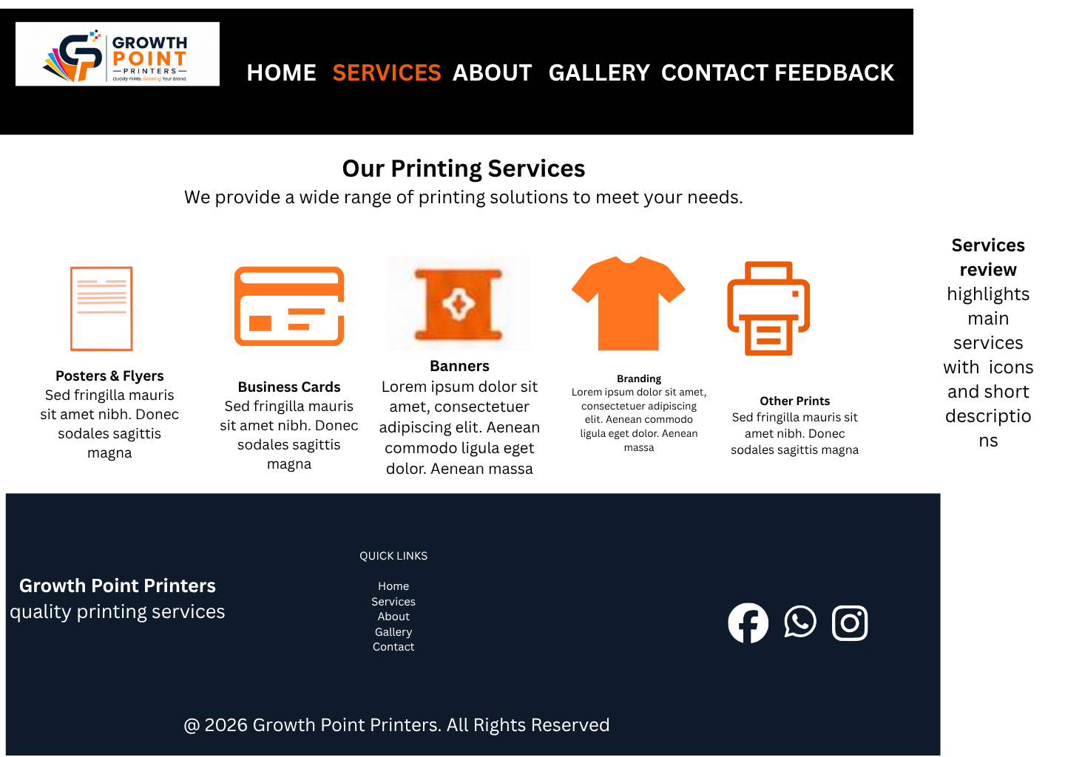
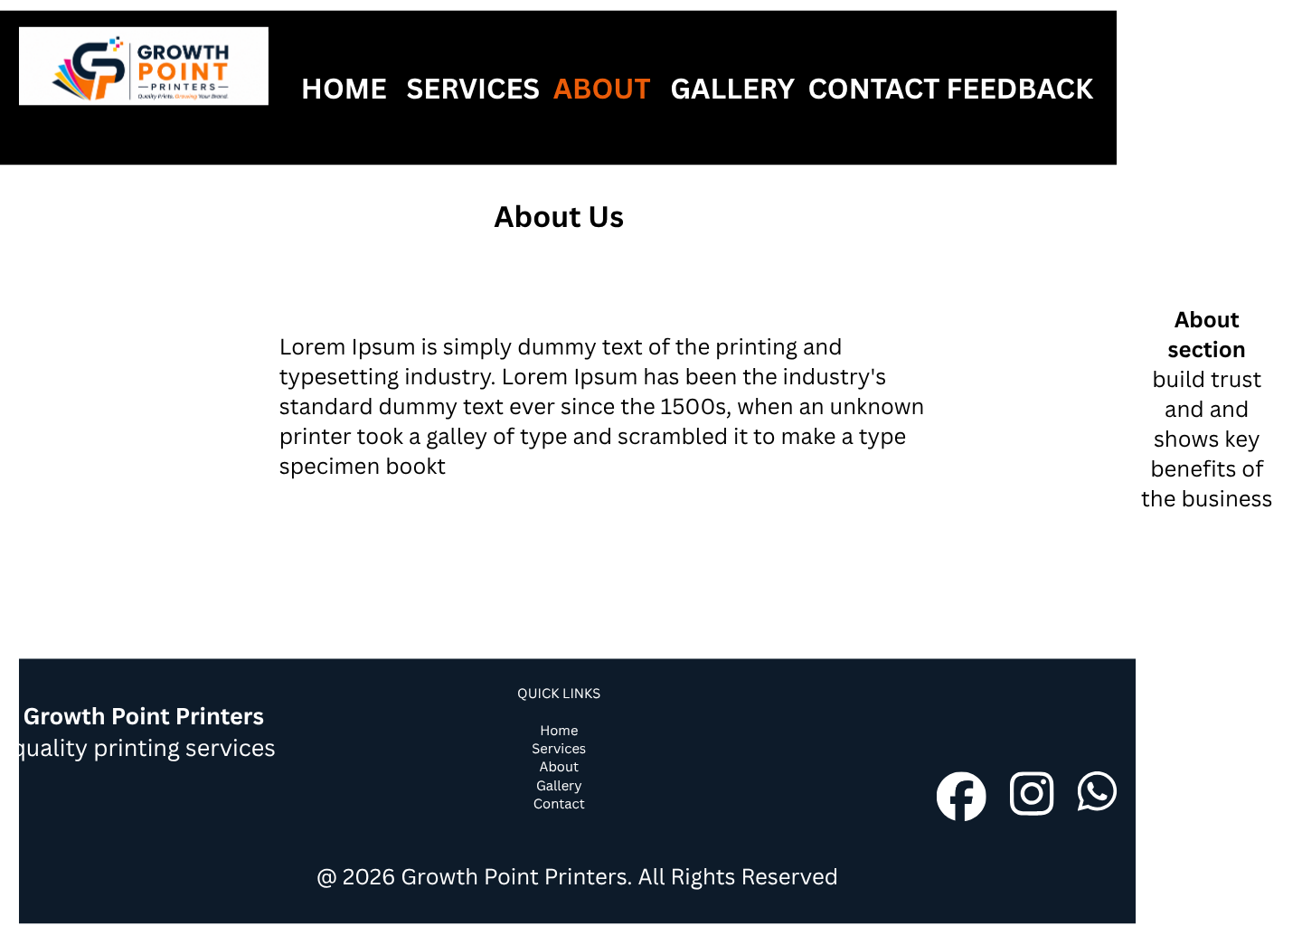
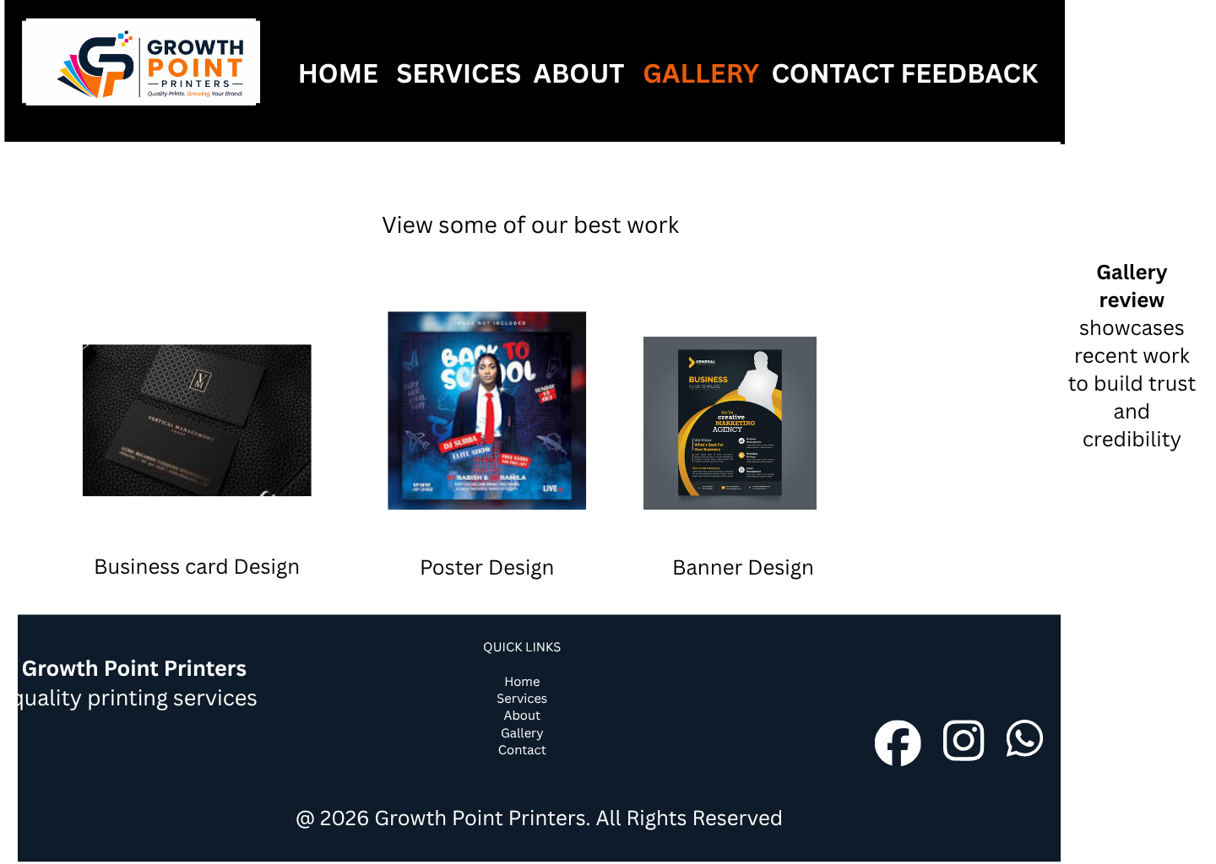

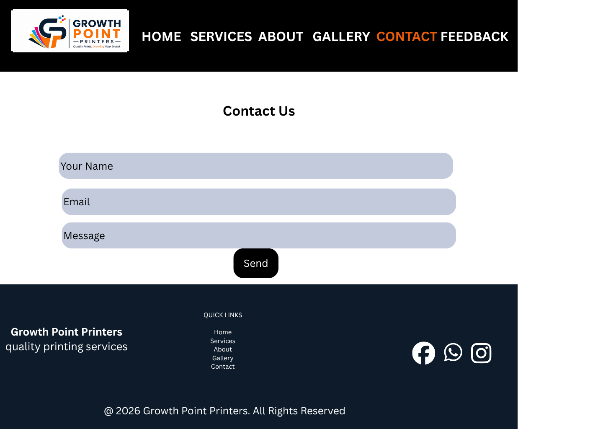
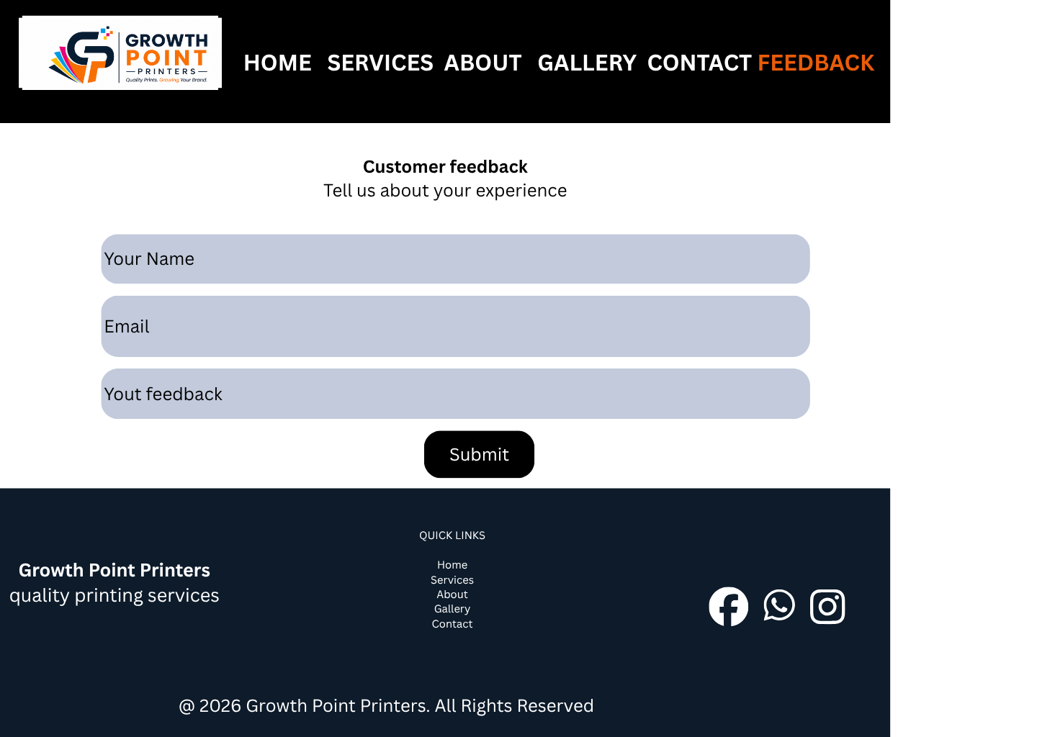

4. Technical Brief
The Growth Point Printers website was developed using modern web development technologies and tools to ensure functionality, responsiveness, and professional presentation.
Technologies Used
HTML5
HTML5 was used to create the structure and content of the website pages. Semantic HTML5 elements such as <header>, <nav>, <main>, <section>, <article>, and <footer> were used to improve page organization, readability, and accessibility.
CSS3
CSS3 was used to style the website and improve the visual appearance. CSS was responsible for:
- page layouts
- colors
- typography
- spacing
- hover effects
- responsive design
Flexbox and Grid layouts were used to improve alignment and page responsiveness across different screen sizes.
JavaScript
JavaScript was used to add interactivity and validation to forms. Form validation was implemented to ensure users enter valid information before submitting forms.
GitHub & GitHub Pages
GitHub was used as the version control and hosting platform for the project. GitHub Pages was used to publish the website online and make it accessible through a public URL.
Form Submit
form Submit was integrated into the Contact and Feedback pages to allow forms to send messages through email using the POST method without requiring server-side programming.

Software Tools Used
Tool | Purpose
Visual Studio Code | Website coding and editing
GitHub | Version control and hosting
GitHub Pages | Website publishing
Google Chrome | Website testing
Mozilla Firefox | Cross-browser testing
Unsplash | Source of website images
Flaticon | Social media icons

Design Considerations
The website was designed with the following considerations:
- user-friendly navigation
- professional business appearance
- consistent page layout
- responsive structure
- visual appeal through images and colors
- accessibility and readability

5. Quality Assurance
Google Chrome Testing
“The website was tested in Google Chrome to ensure proper layout, navigation, and responsiveness.”
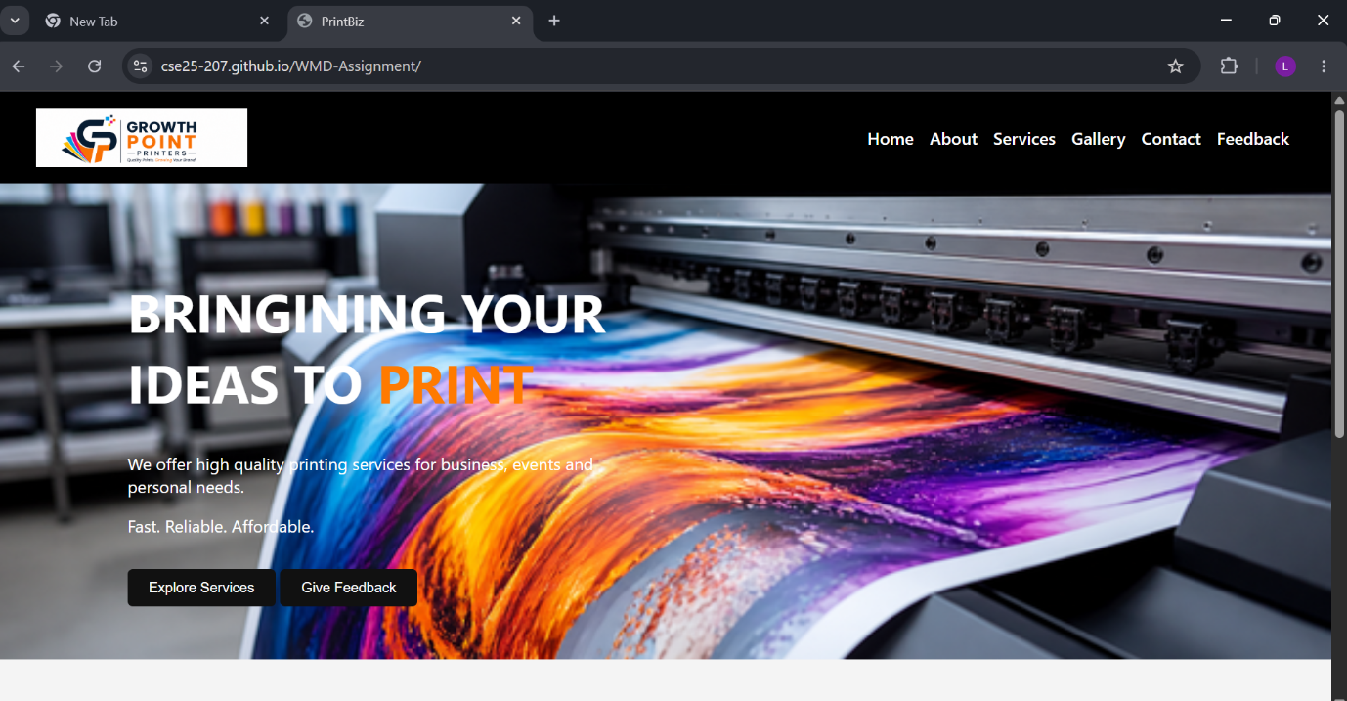

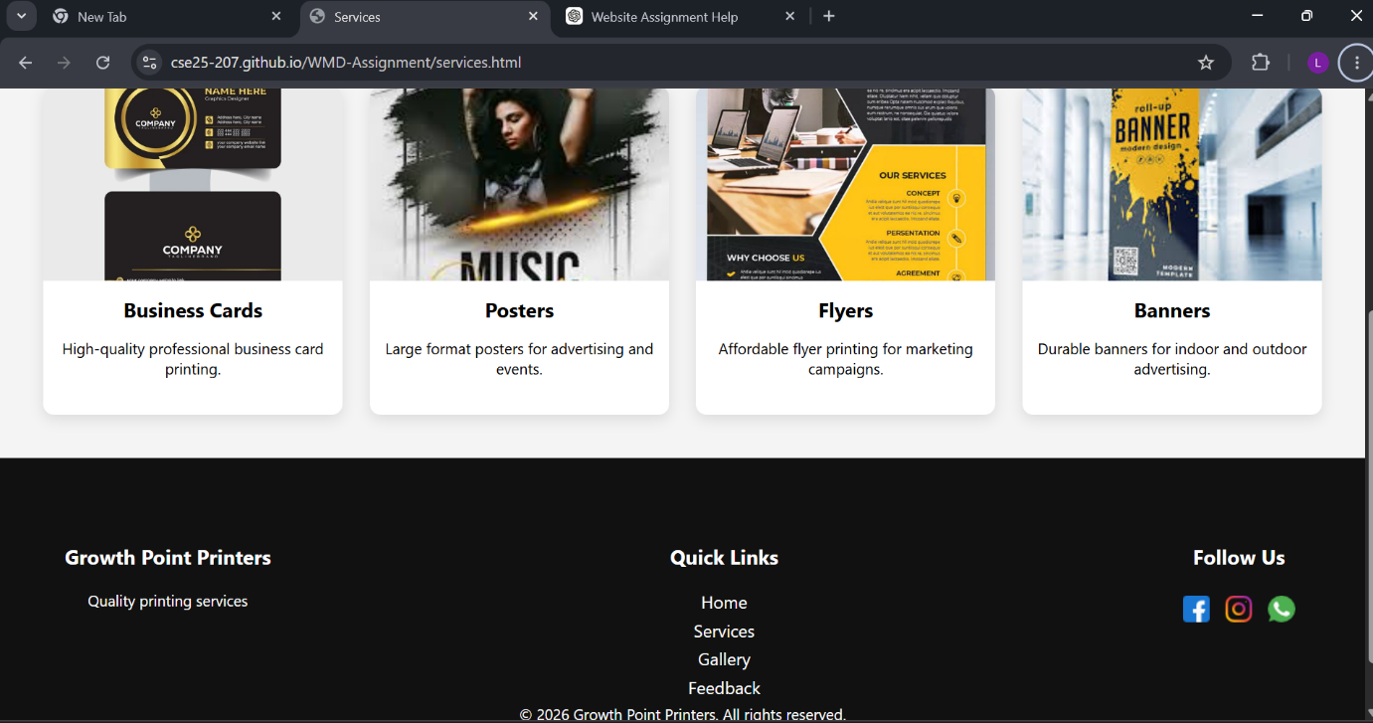

Mozilla Firefox Testing
“The website was tested in Mozilla Firefox to ensure compatibility across browsers.”
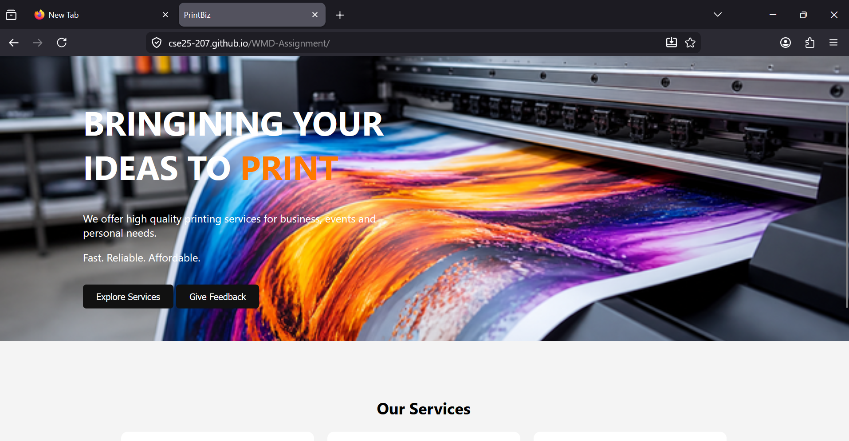

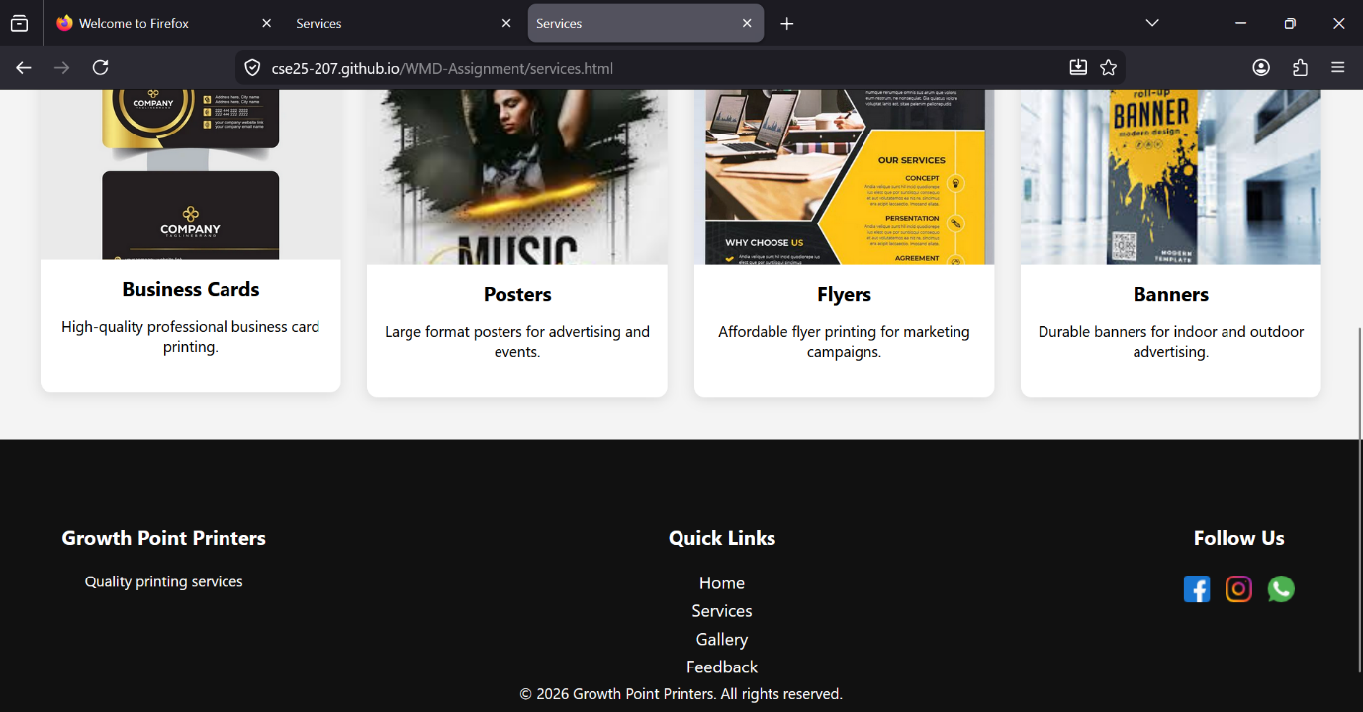

Microsoft Edge Testing
“The website was tested in Microsoft Edge to ensure compatibility across browsers.”
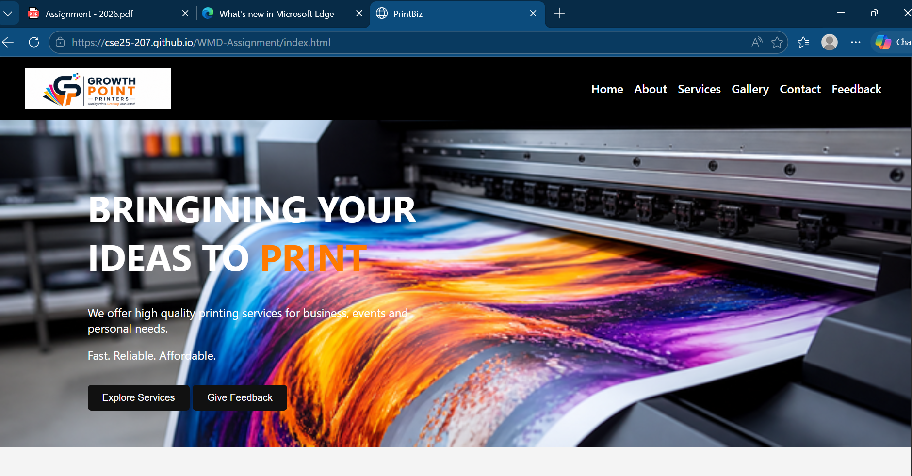

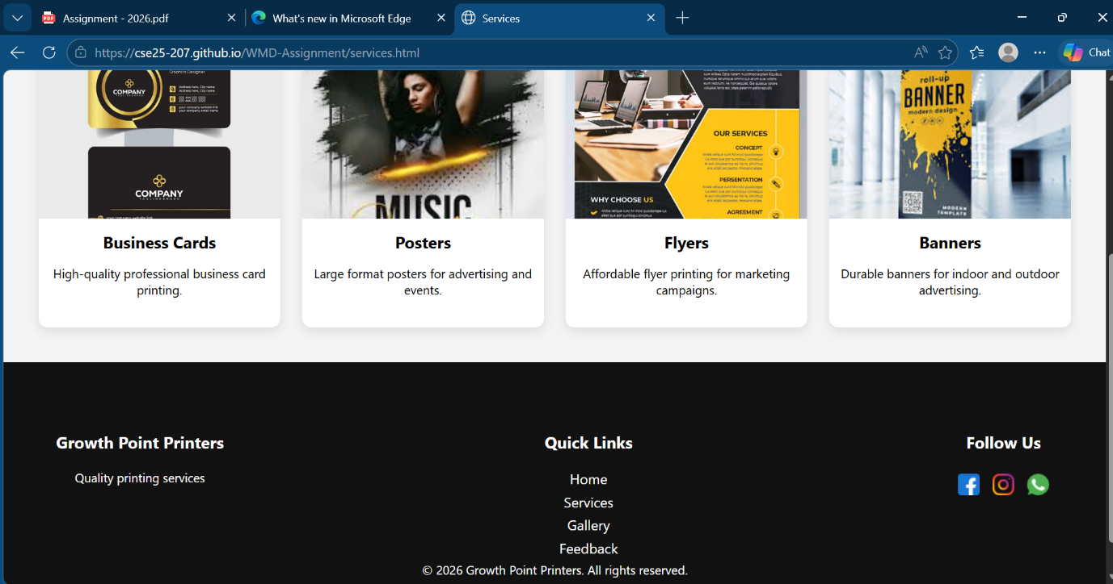

Mobile Device Testing
“The website was tested using Chrome browser on a mobile device to ensure responsive display on smaller screens.”
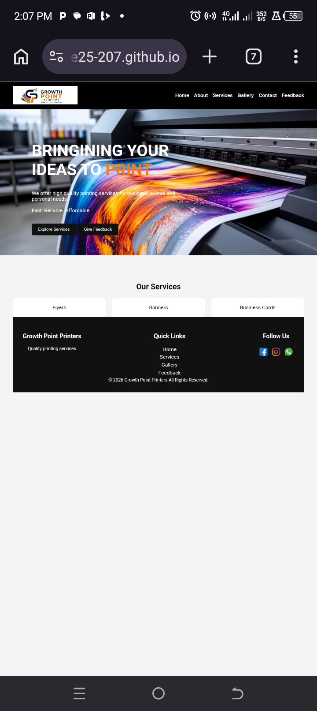
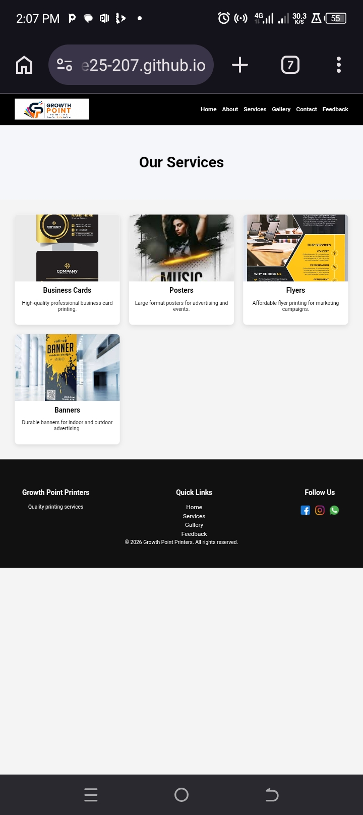
6. Publishing & Promotion
The website was published using GitHub Pages. GitHub was used as the online repository to store and manage all website files including HTML, CSS, JavaScript, and image resources.
The website files were uploaded to a GitHub repository and then hosted publicly using GitHub Pages to make the website accessible online through a web browser.
Git commands such as:
- git init
- git add .
- git commit -m "Initial Website Upload"
- git push origin main
were used during the publishing process.
The final published website can be accessed through the GitHub Pages URL provided below.
Repository URL:
https://github.com/cse25-207/WMD-Assignment.git
Website URL:
https://cse25-207.github.io/WMD-Assignment/

7.Future Improvements and Recommendations
Future Developments
Improved Responsiveness
Future versions of the website could include a fully responsive navigation menu such as a hamburger menu for mobile devices to improve usability on smaller screens.
Online Ordering System
An online ordering and quotation system could be added to allow customers to place printing orders directly through the website.
User Accounts
A customer login and registration system could be implemented to allow users to manage their orders and track printing requests.
Database Integration
The current forms use FormSubmit for email functionality. In the future, a database system such as MySQL could be integrated to store customer feedback, messages, and order information securely.
Advanced Animations
Additional animations and interactive effects could be added using advanced JavaScript libraries to improve user experience and visual appeal.
Search Functionality
A search feature could be implemented to help users quickly locate services and information on the website.
Social Media Integration
Future improvements may include direct social media feeds and sharing functionality to improve customer engagement and marketing.
Enhanced Security
Additional security measures such as CAPTCHA systems and server-side validation could be implemented to improve form protection and reduce spam submissions.
Recommendations
It is recommended that the website continue to be updated regularly with new gallery images, printing services, promotions, and customer testimonials in order to maintain user interest and business relevance.
Regular testing across different browsers and devices should also continue to ensure compatibility and consistent performance.

